ASSESSMENT TOOL-OUTPUT PREDICTION
NAME: KONGALAVEETI VENKATA MALLIKHARJUNA REDDY
REG NO:192525109
COURSE NAME : DATA STRUCTURES
COURSE CODE : CSA0307

QUESTION 1: PROGRAM FOR COUNT THE OCCURRENCE OF AN ELEMENT
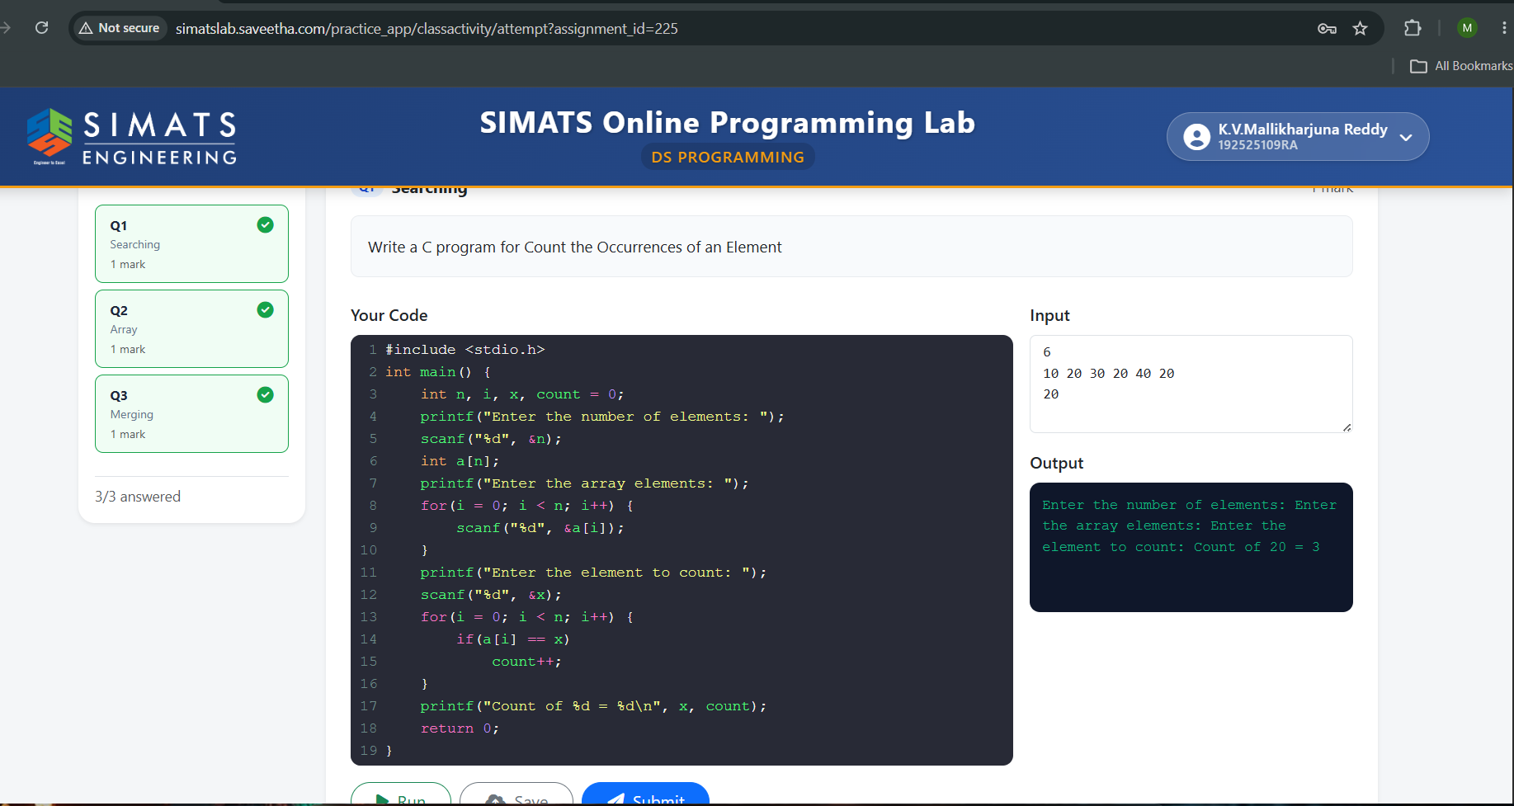

QUESTION 2: C PROGRAM FOR BINARY SEARCH
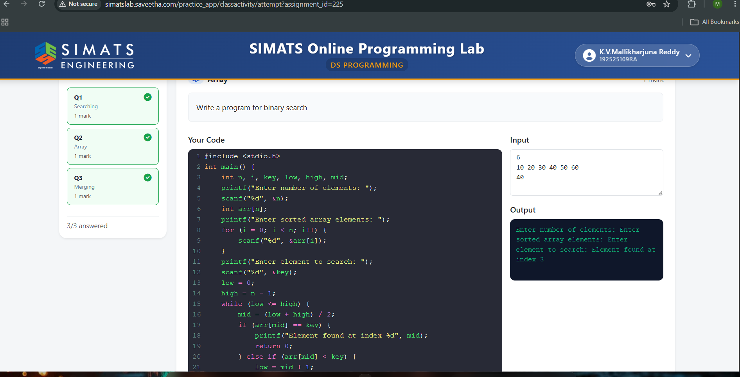

QUESTION 3: C PROGRAM FOR MERGE TWO ARRAYS
